**Movie Review Website Documentation**

**1. Homepage**

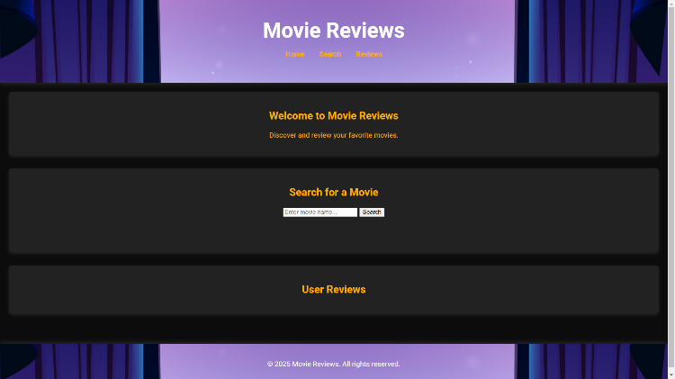The homepage is the entry point of the platform, where users are welcomed with a clean and engaging interface. It typically features a navigation menu and search functionality.

**2. Searching**

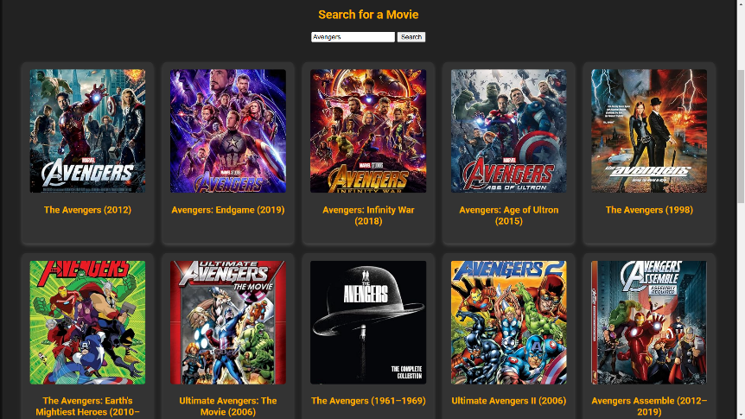The search feature allows users to find specific movies using keywords, genres, or actors. A search bar is prominently placed, where users can type their queries and receive a list of relevant results. Search results often include movie titles and year of movie release to help users make selections quickly.

**3. Selecting**

After searching, users can browse through a list of movies that match their query. Clicking on a movie selection will take the user to the detailed movie page. Selection screens often provide additional sorting and filtering options like popularity, release date, or genre preferences**.**

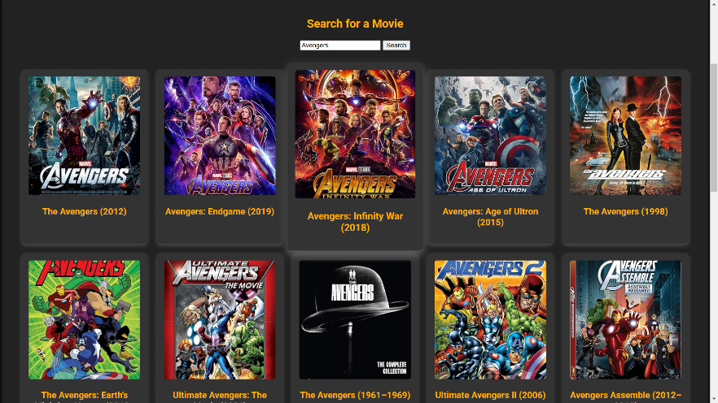

**4. Movie Details**

This page contains information about a selected movie. Key elements include the movie title, synopsis, ratings, and reviews from other users. Users may also see posters and recommendations for similar movies. An option to leave a review or rate the movie is usually available.

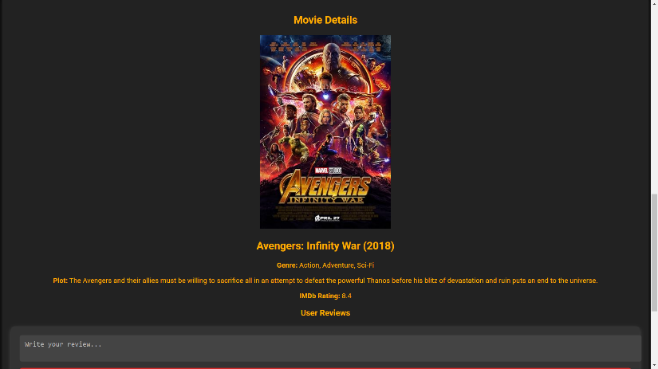

**5. Writing a Review**

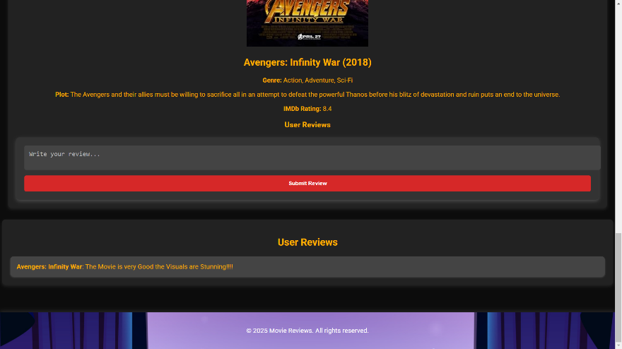Users can express their opinions by writing a review for a movie. This section typically includes a text box for the review and an option to submit and display featured reviews prominently.

**6. User Reviews**

This section displays reviews submitted by other users. Reviews may include user ratings, written opinions, and engagement metrics such as likes or comments. Sorting options might be available, such as sorting by most helpful, most recent, or highest/lowest ratings. Users can interact with reviews by liking, replying, or reporting inappropriate content.

